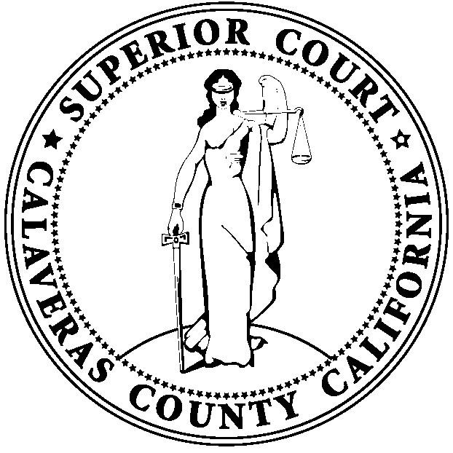

CALAVERAS COUNTY

SUPERIOR COURT

LOCAL COURT RULES

PROPOSED AMENDMENTS: To be Effective JANUARY 1, 2026

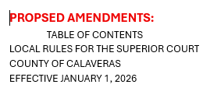

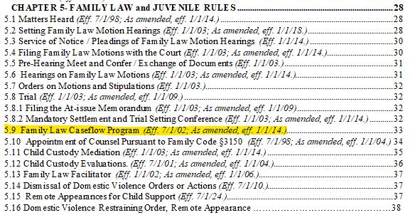

Proposed Amendments are:
  - Family Law Caseflow Program (Eff. 7/1/02; As amended, eff. 1/1/14.)(Revised 1/1/2026)

- Purpose - The goal of Family Law Caseflow Program is to encourage timely and just resolutions in parentage and marital termination actions. Notwithstanding involvement in the caseflow program, any party may file a motion on the Family Law and Motion calendar. Likewise, when appropriate, any party may file an at-issue memorandum requesting the setting of a trial date. The Family Law Caseflow Program calendar is not a Law and Motion calendar.

ADD LOCAL FORM:

Declaration – Ability to Pay Infractions Only

